**Chapter 4**

**Differentiation of Functions of Several Variables**

**4.7 Maxima/Minima Problems**

**Section Exercises**

**For the following exercises, find all critical points.**

311. 

Answer: 

313. 

Answer:  

**For the following exercises, find the critical points of the function by using algebraic techniques (completing the square) or by examining the form of the equation. Verify your results using the partial derivatives test.**

315. 

Answer: Maximum at 

317. 

Answer: Relative minimum at 

**For the following exercises, use the second derivative test to identify any critical points and determine whether each critical point is a maximum, minimum, saddle point, or none of these.**

319. 

Answer: The second derivative test fails. Since  for all *x* and *y* different from zero, and  when either *x* or *y* equals zero (or both), then the absolute minimum occurs at 

321. 

Answer:  is a saddle point.

323. 

Answer:   is a saddle point.

325. 

Answer:  is a local maximum.

327. 

Answer: Relative minimum located at 

329. 

Answer:  is a saddle point.

331. 

Answer:  and  are saddle points;  is a relative minimum.

333. 

Answer:  is a relative maximum.

335. 

Answer:  is a saddle point.

337. 

Answer: The relative maximum is at 

339. 

Answer:  is a saddle point and  is the relative minimum.

**For the following exercises, determine the extreme values and the saddle points. Use a CAS to graph the function.**

341. **[T]** 

Answer: A saddle point is located at 

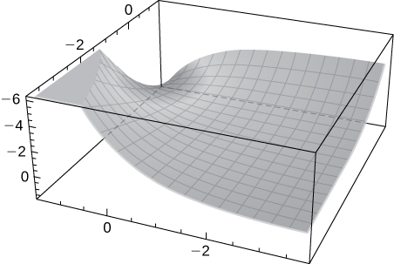

343. **[T]** 

Answer: There is a saddle point at  local maxima at  and local minima at 

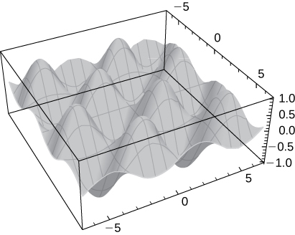

**Find the absolute extrema of the given function on the indicated closed and bounded set **

345. Find the absolute maximum and minimum values of  on the region 

Answer: (0, 1, 0) is the absolute minimum and (0, -2, 9) is the absolute maximum.

347.  on 

Answer: There is an absolute minimum at (0, 1, -1) and an absolute maximum at (0, -1, 1).

349. Find the points on the surface  that are closest to the origin.

Answer: 

351. The sum of the length and the girth (perimeter of a cross-section) of a package carried by a delivery service cannot exceed  in. Find the dimensions of the rectangular package of largest volume that can be sent.

Answer:

353. Find the point on the surface  nearest the plane  Identify the point on the plane.

Answer: 

355. A company manufactures two types of athletic shoes: jogging shoes and cross-trainers. The total revenue from units of jogging shoes and ** units of cross-trainers is given by  where  and are in thousands of units. Find the values of *x* and *y* to maximize the total revenue.

Answer:  and 

357. Find the maximum volume of a cylindrical soda can such that the sum of its height and circumference is  cm.

Answer:  cm3

This file is copyright 2016, Rice University. All Rights Reserved.